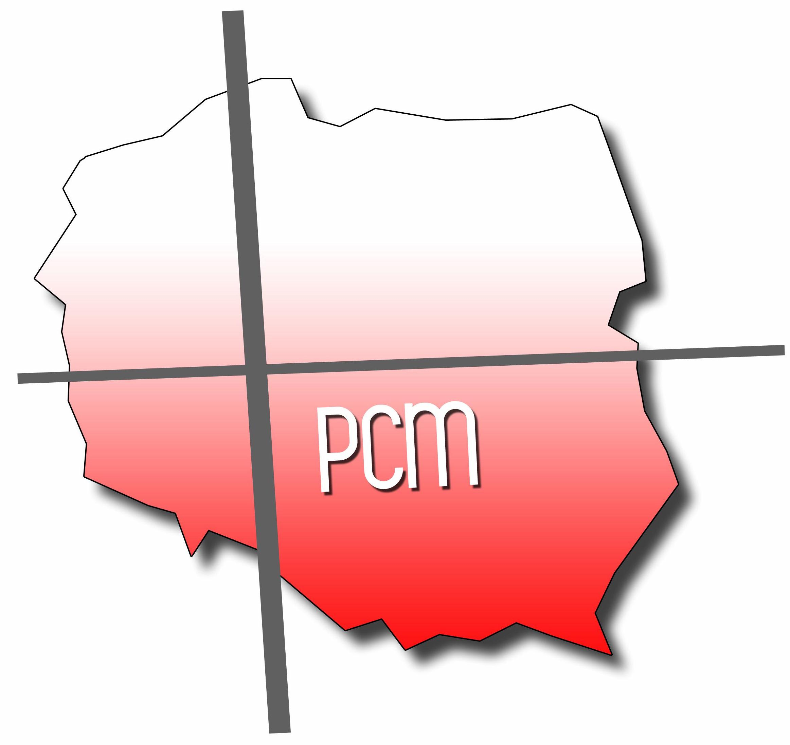
Serving the people of Poland since 1954
Polish Christian Ministries
March 2021

“Come, let us sing to the LORD! Let us give a joyous shout to the Rock of our salvation! Let us come before Him with thanksgiving. Let us sing Him psalms of praise. For the LORD is a great God, the great King above all gods.” Psalm 95:1-3

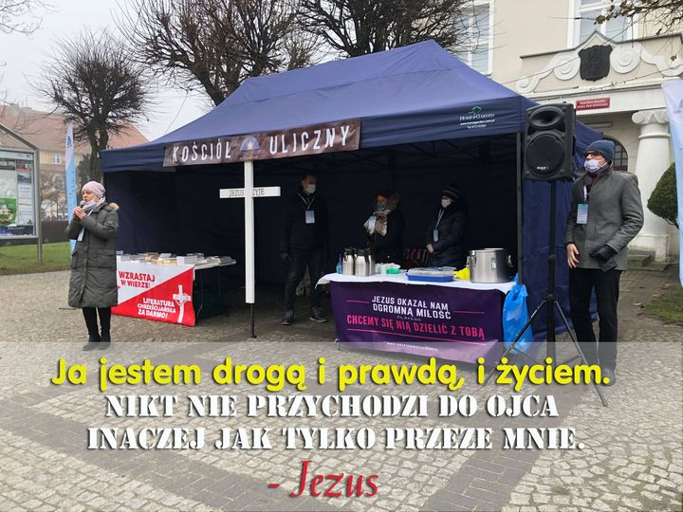
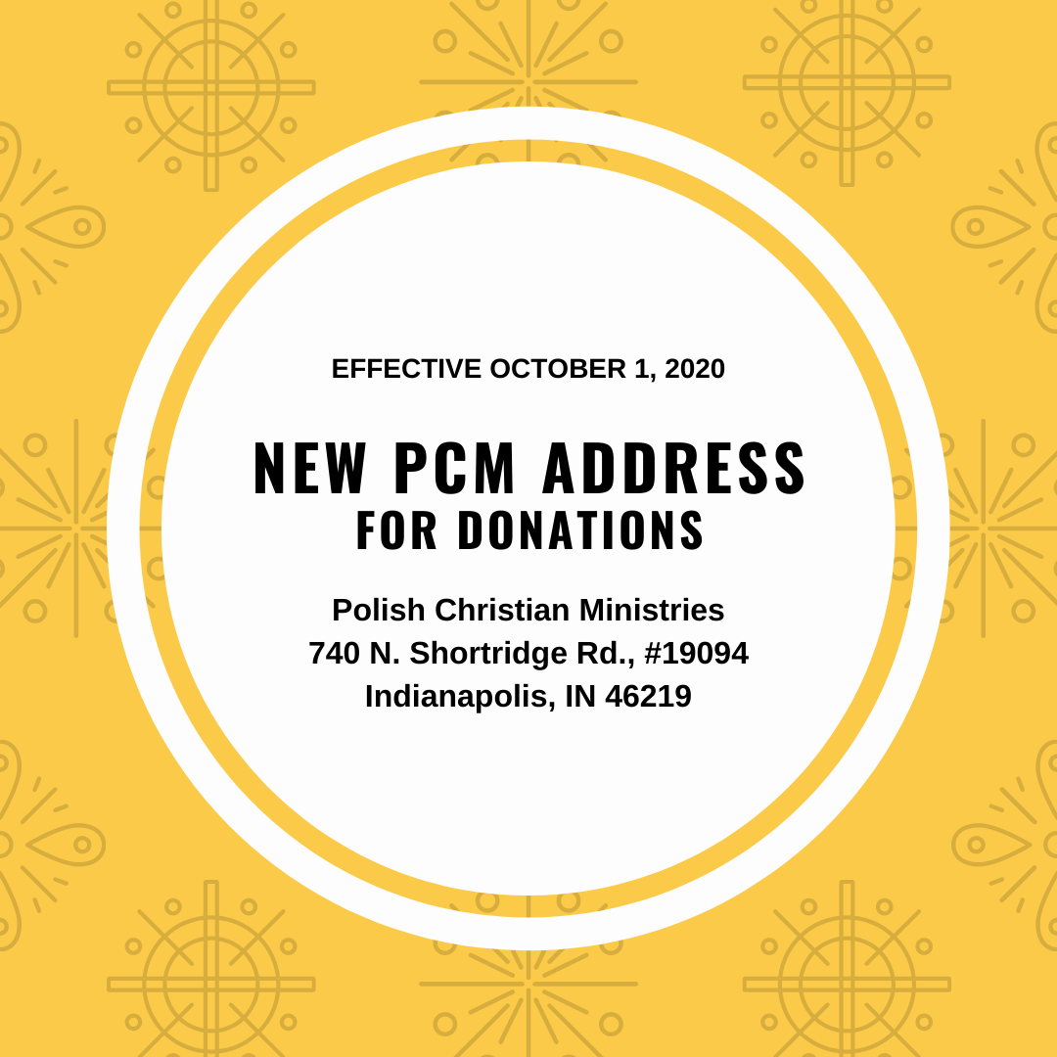
STREET CHURCH

“I am the way, the truth, and the life. No one comes to the Father except by Me” – Jesus.

Pastor Arek Kotlewski and his team from the church in Działdowo are often on the streets, offering literature, coffee and pastries, prayer, and words of hope to the people of their community. During these days of crisis, they are a visible demonstration of God’s steadfast love. Arek will be sharing with us in our next Zoom prayer session.

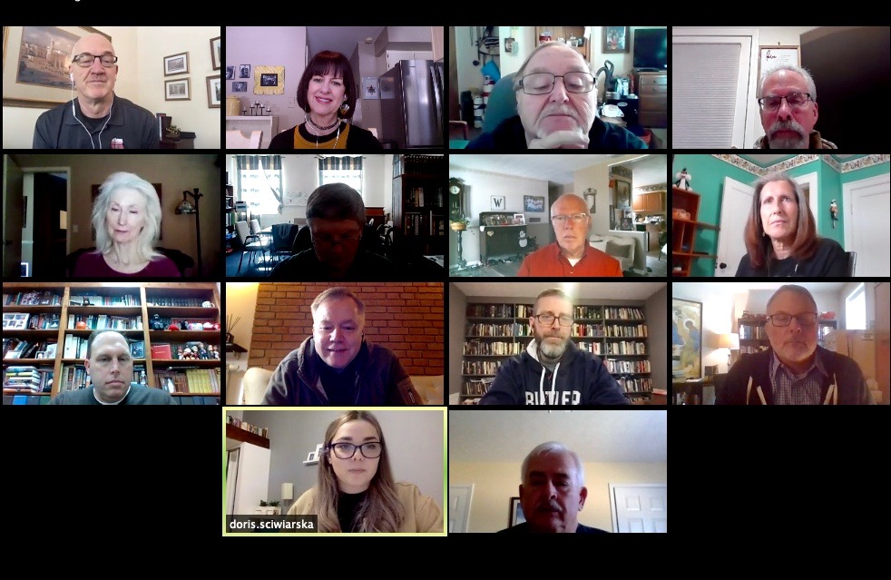
ZOOM PRAYER SESSION

On February 8 we hosted a special Zoom prayer session with Pastor Jarek Ściwiarski from Dąbrowa Górnicza. He shared a ministry update and needs for prayer. We found out rather quickly that leaders in the States and in Poland are facing similar challenges. It was so good to hear from one another and pray together. A big thank you to each one who joined us and to Jarek’s daughter, Doris, who did such a great job translating.

Our next Zoom session will be Monday, March 8, at 11:00 ET (link will be sent separately).
Our special guest will be Pastor Arek Kotlewski from Działdowo.
Hope you can join us!
WARSAW WEST

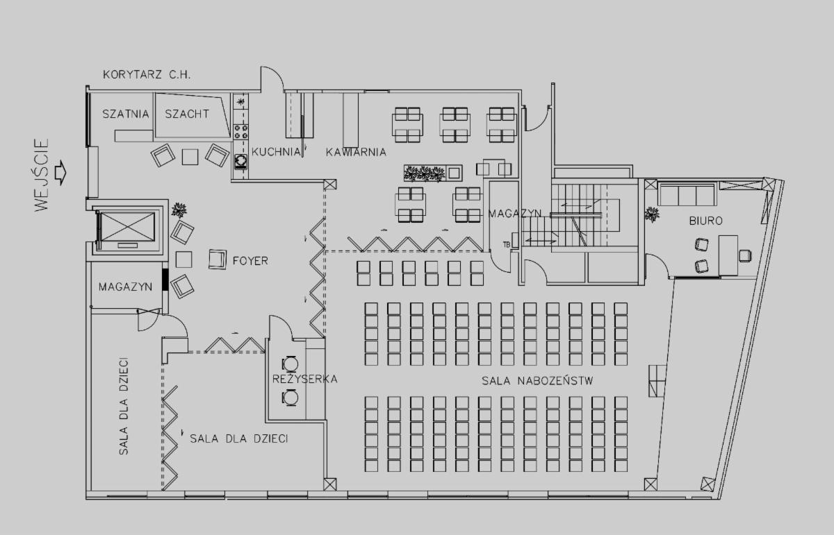

One of the exciting projects included in the “3 for 3 in 3” initiative is the renovation of the new meeting place for “Christian Fellowship West” in the Bemowo district of Warsaw. They have signed a contract to lease a wonderful space in one of the local shopping malls. It was previously a children’s play area so a lot of renovation is still to come. They can’t wait to worship God and introduce people to Jesus in this place.
Check out this video of their new place!

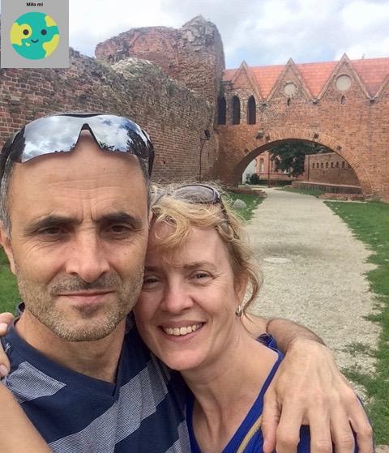
TRANSFORMATION

Wojciech Lemke (pronounced “Voy-check Lem-keh”) is a pastor of the church in Gdynia on the Baltic coast. His Living Link church is the Union City Christian Church in Richmond, KY. Wojciech and his wife, Iwona, along with their four grown sons, serve the congregation with a special emphasis on helping needy children. His testimony is one of transformation – from despair to hope, from sadness to joy, from meaninglessness to a reason for living. For more about Wojciech and our Polish ministry partners, check out our “Polish Christian Ministries” page on Facebook. We give thanks to God for each of our Polish partners and their stories of God’s great grace.

$191,289.73 TO DATE IN MEMORY
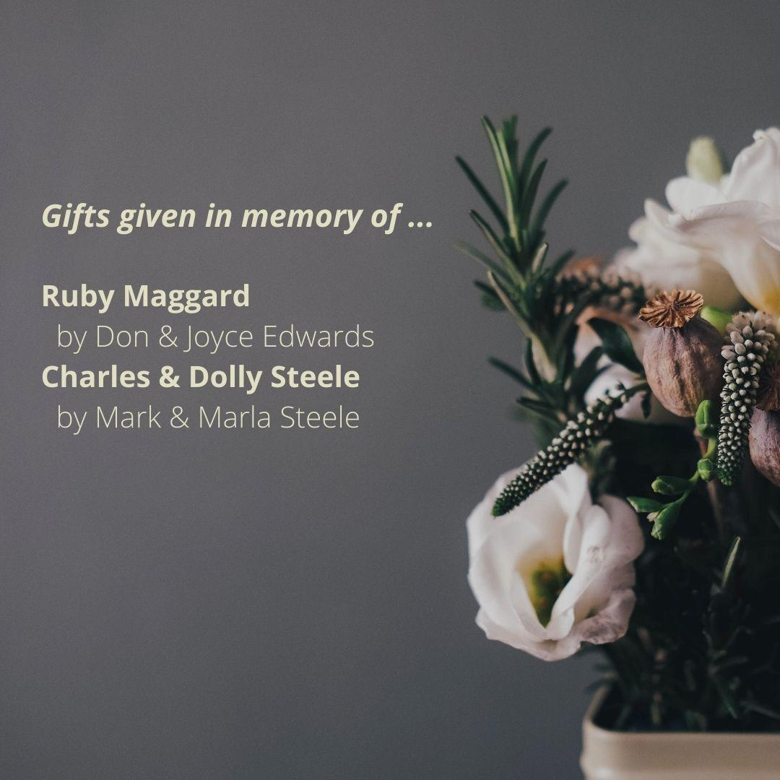
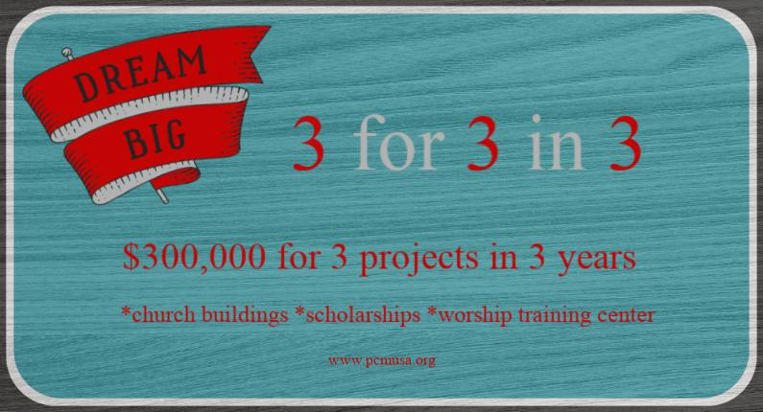

PRAYER REQUESTS

Praise God for …
. . . each of our U.S. supporting churches. Here are the top 15 in 2020:

TOP 15 SUPPORTING CHURCHES 2020

Tomoka Christian Church, Ormond Beach, FL
Compassion Christian Church, Savannah, GA
Church of Christ at Manor Woods, Rockville, MD
Brighton Christian Church, Brighton, MI
Traders Point Christian Church, Zionsville, IN
Fairmount Christian Church, Mechanicsville, VA
Central Christian Church, Ocala, FL
Southport Heights Christian Church, Indianapolis, IN
OceanPointe Christian Church, Middletown, RI
New Hope Christian Church, Whitestown, IN
Islands Christian Church, Savannah, GA
Salem Christian Church, Richmond, KY
Kissimmee Christian Church, Kissimmee, FL
Lighthouse Christian Church, Oceanside, CA
North Liberty Church of Christ, North Liberty, IN

. . . the fellowship in Kutno which became an official mission station of the church in Dąbrowa Górnicza in February
. . .each of our Polish partners who continually give of themselves to build up the churches in Poland.
Please pray for . . .

. . . our Polish partners to have good health and renewed courage as they minister during these difficult times.
. . .Henryk Karasiewicz as he continues to undergo cardiac rehabilitation.
. . .a spirit of unity amongst Polish pastors and their leaders.
. . .funds to winterize the chapel at Ostróda Camp.
. . .a worship leader for the church in Sandomierz.
. . .the churches in Lidzbark Welski and Radom as they both are in need of pastors.
. . .Warsaw West as they begin renovations in March.
. . .Pabianice as they hope to raise funds to finish construction of their new space in Łódż.
. . .Ciechanów as they seek to raise funds to insulate the roof and walls of their building.

If your church is interested in having PCM come to your congregation,
please contact David at dave.hatfield777@gmail.com or call him at 810-923-0226.

All donations to Polish Christian Ministries should be sent to:
740 N Shortridge Rd., #19094, Indianapolis IN 46219-9403

Donations may also be made via our website:
http://www.pcmusa.org/ Click on: Ways to Give

(410-688-3294 Office) pcm@pcmusa.org (email)
Other correspondence may continue to be sent to: 1212 Schucks Rd, Bel Air MD 21015

