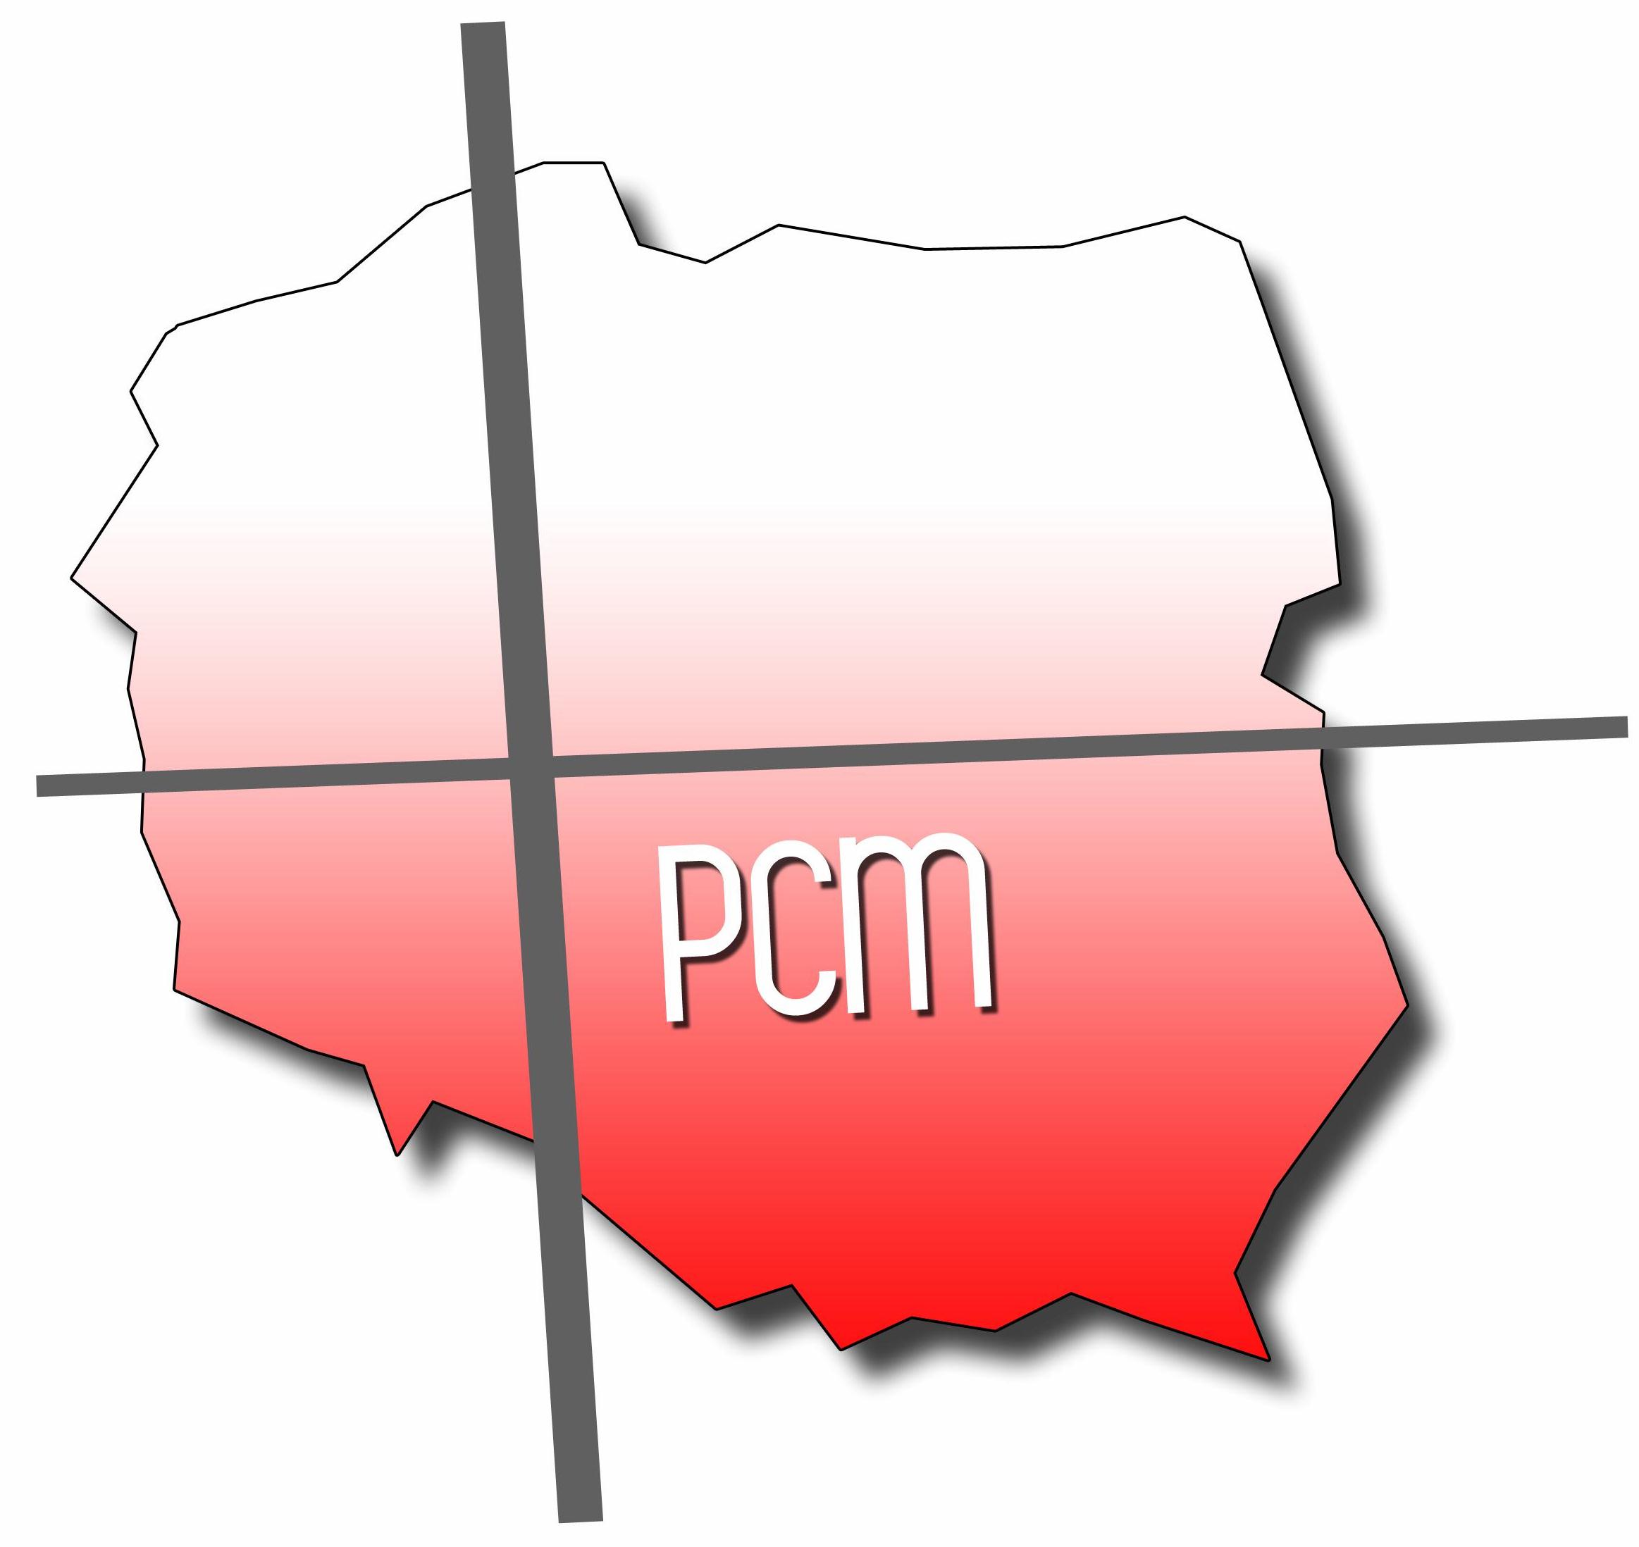
Serving the people of Poland since 1954
Polish Christian Ministries
February 2021

“The LORD reigns, He is robed in majesty; the LORD is robed in majesty and is armed with strength. The world is firmly established; it cannot be moved. Your throne was established long ago; You are from all eternity.” Psalm 93:1-2

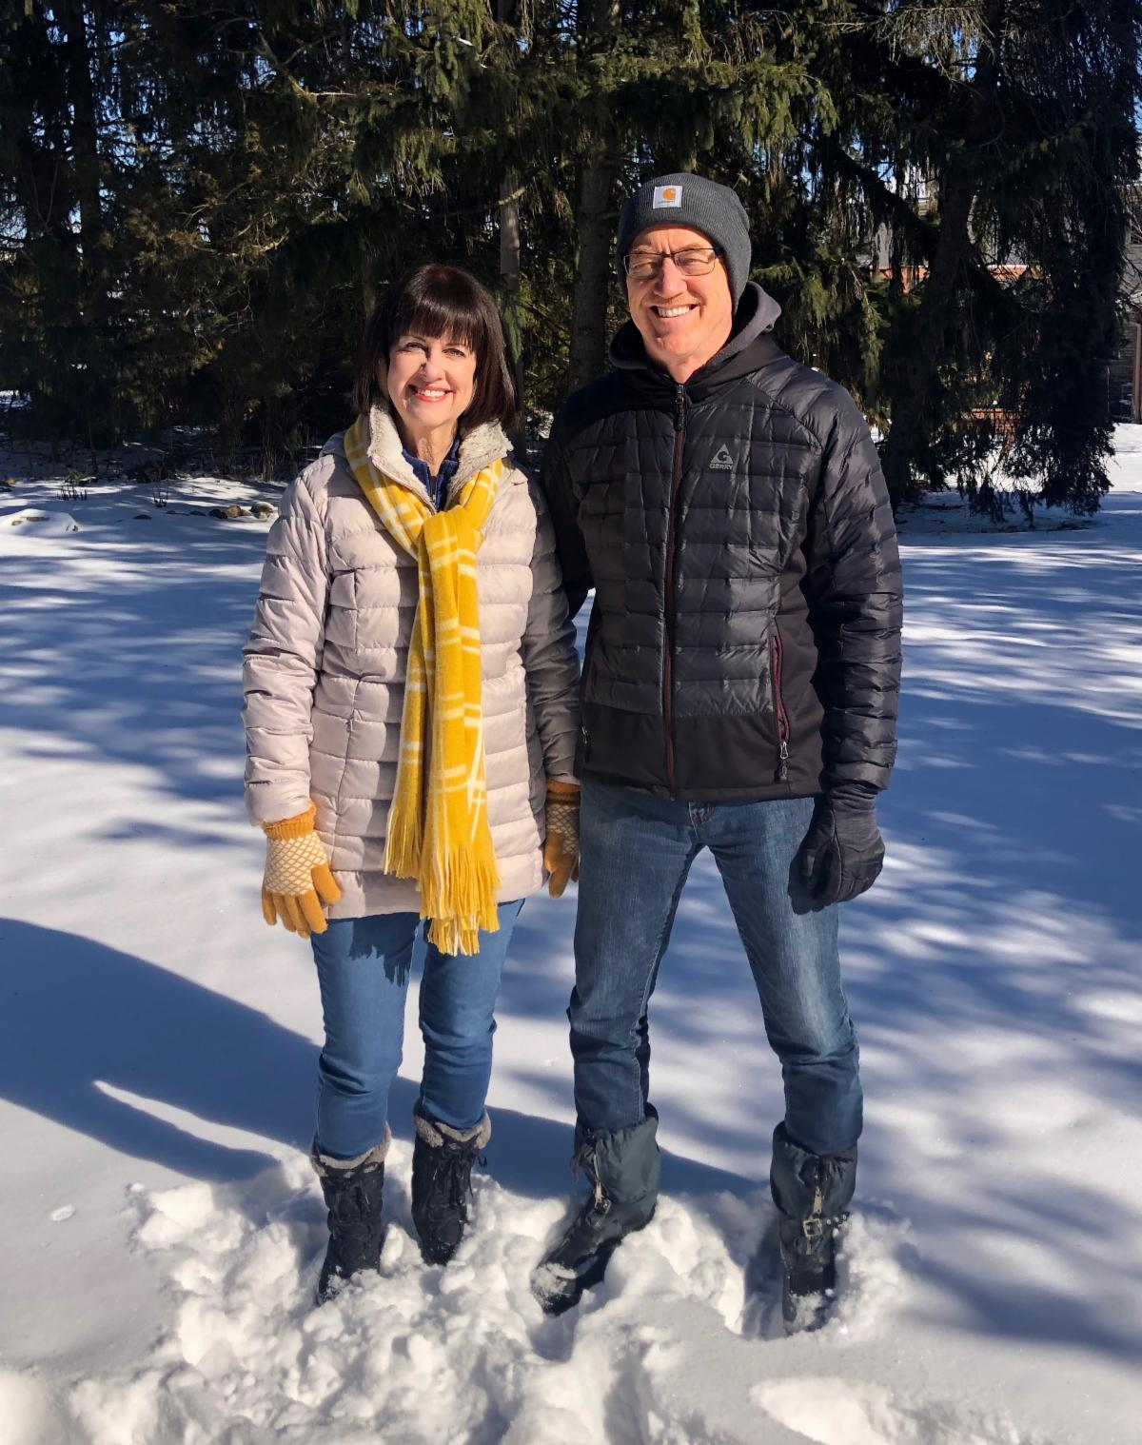
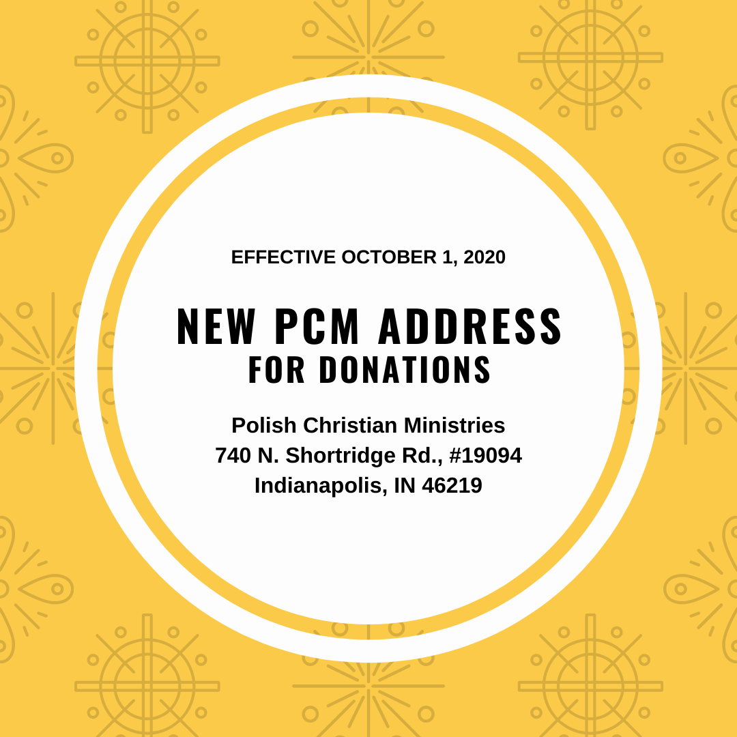
YOU’RE INVITED!

On Monday, February 8, at 11:00 EST, we will be hosting our first Zoom prayer meeting with Jarek Sciwiarski, the pastor of the church in Dąbrowa Górnicza. Our plan is to host Zoom prayer sessions with our Polish partners at least once per month on Mondays. We believe prayer not only binds us together, but it is the place from which all kingdom work springs forth.

Click on the link for a short video inviting you to join us. Hope to see you on the 8th!

Zoom Meeting Invite

Topic: Prayer for Dąbrowa Górnicza, Poland
Time: Feb 8, 2021 11:00 AM EST

Join Zoom Meeting
https://us02web.zoom.us/j/84073852461?pwd=ZVNVc1NERVBpK0daWlNJVlk2YWhmdz09

Meeting ID: 840 7385 2461
Passcode: 011825

READY FOR WINTER

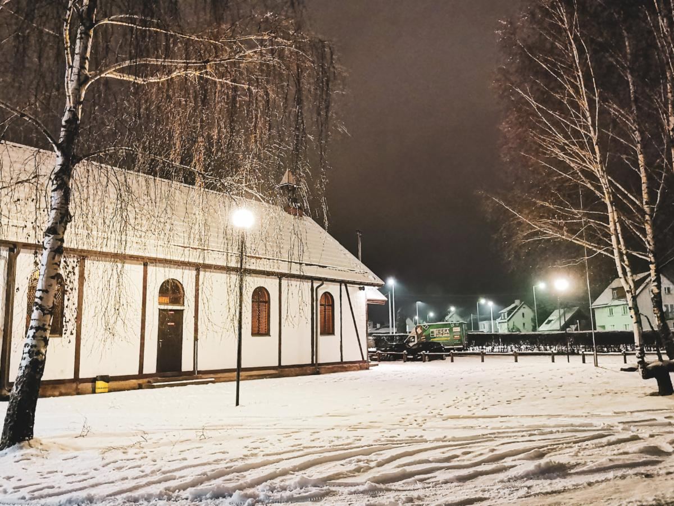
Winter has officially arrived in Poland. The last few winters have been fairly mild, so most Polish children and many snow-loving adults are excited that a “real winter” has finally come. Ostróda Camp, where many of our summer initiatives take place, is now blanketed in snow. Camp Director Bartek Zdanowicz continues to oversee renovations and the next big project is to winterize the chapel so that the facility can be used year-round. If you would like to give, donations may be designated for the “Ostróda Camp chapel.” We thank God for Ostróda Camp and all the lives that are forever changed in that place.

100-YEAR CELEBRATION
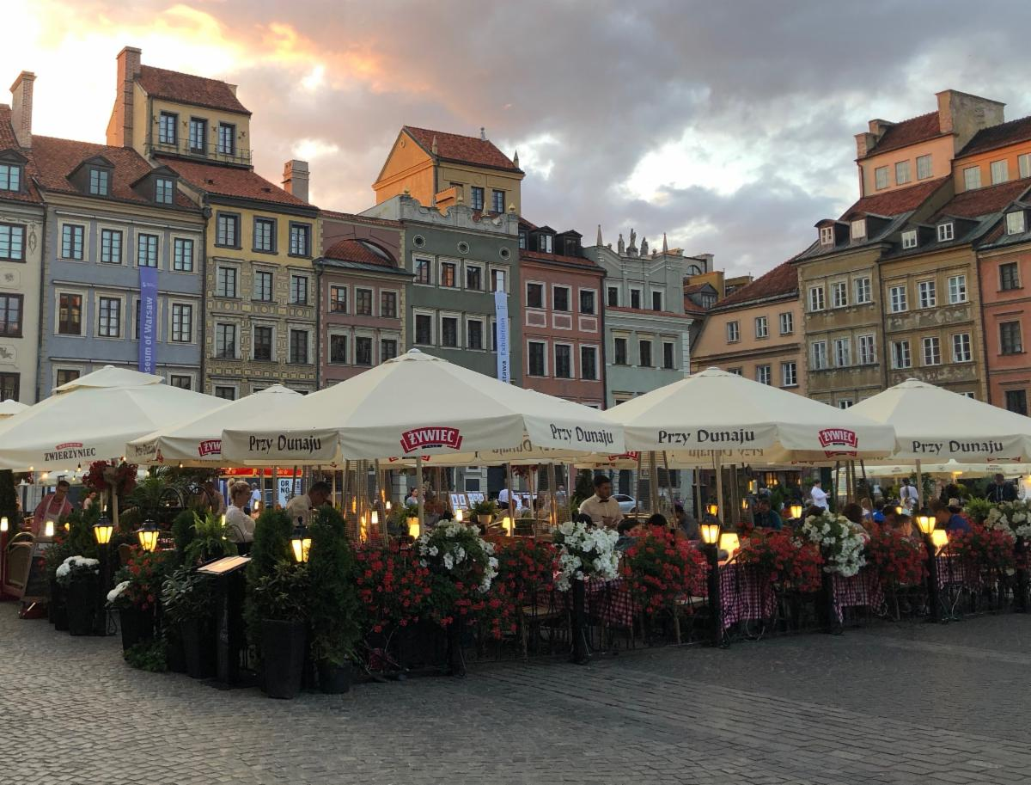
Someday, we hope to once again welcome teams to Warsaw and stroll through the Old Town together. Unfortunately, due to the uncertainties surrounding the Covid-19 pandemic, the 2021 Global Gathering has been pushed to June 19-22, 2022. While there will still be the 100-year celebration in June 2021, PCM will not be coordinating the summer trips as previously planned. If the European borders should happen to open before May 1st, there may be a few PCM representatives who will make the journey to join in the celebration. We’ll keep you posted.

IN MEMORY

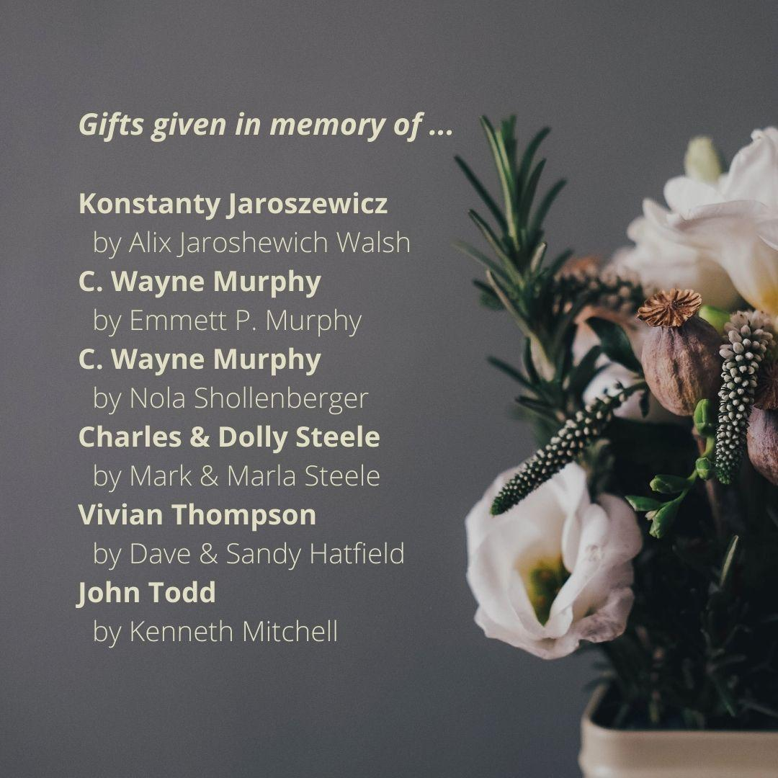

CHAMPIONS FOR MISSIONS
It is always a blessing to partner with mission teams across the U.S. as together we serve our brothers and sisters in Poland. Although we have met many who are passionate for missions, there are a few who have stood out as an inspiration to us all. We recently learned of the passing of these two ladies who were both deeply involved in missions and supported the work in Poland. Vivian and Faith were true champions on behalf of God’s heart for the world. We honor them for their many years of service, celebrate the many lives they have touched, and thank God for their global focus. May many more rise up with similar passion and courage to make Jesus known among the nations.

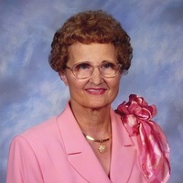
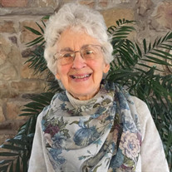

FAITH EUNSON LONG
August 27, 1932 – November 10, 2020

A schoolteacher for many years, Faith began a Bible club for kids in the neighborhood where she lived. She served in various ministries at the Bloomsburg Christian Church in Bloomsburg, PA – including being the mission team chairman for many years. She was passionate to share Jesus – through teaching, music, volunteer work, and even her cooking. Her wisdom and love touched many. Thank you, Faith!

VIVIAN C. THOMPSON
August 16, 1931 – January 8, 2021

Vivian’s desire to share the Gospel pervaded her life. She traveled to 55 countries on six continents. She welcomed hundreds of missionaries and ministry workers into her home. Serving on the mission team at the First Church of Christ in Washington, NC, her influence also reached to the nation of Poland. Vivian has been described as “forever a beacon of light for missions and missionaries around the world.” Thank you, Vivian!

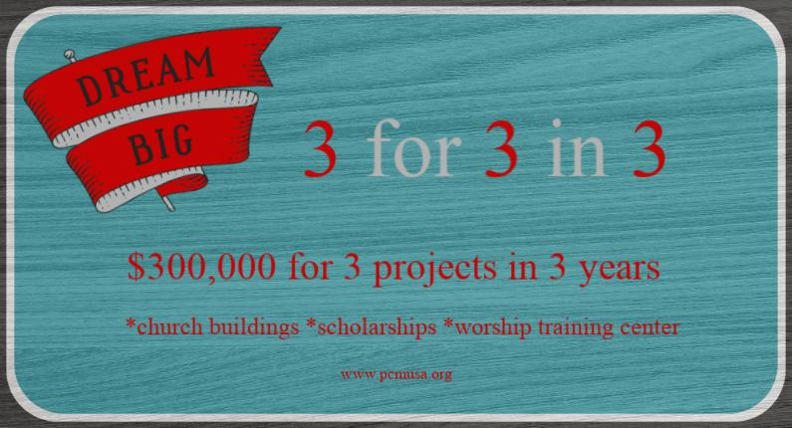
$163,791.67 TO DATE

Funds sent in 2020:
Church buildings/renovation/furnishing projects: $124,540 ($300,000+ still needed) to Biała Podlaska, Płock, Warsaw West, Łódż Victory, Pabianice, Dąbrowa Górnicza, Sosnowiec, Bielsk Podlaski, Białogard, Ciechanów, Lidzbark Welski, Połczyn Zdrój, Grudziądz, and Łódż
CSM Worship Training Center: $29,000
($110,000 still needed)
Scholarships for Polish students/interns: $3,000

PRAYER REQUESTS
Praise God for. . .

. . .U.S. churches and individuals who continue to provide monthly support for our Polish pastors and ministry workers
. . .the funds received for the “3 for 3 in 3” initiative
. . .the various outreaches over the holidays to share the hope of Jesus.
. . .the fellowship in Kutno which will become an official mission station of the church in Dąbrowa Górnicza this month
. . . each of our Polish partners who continually give of themselves to build up the churches in Poland

Please pray for. . .

. . .our Polish partners to have good health and renewed courage as they minister during these difficult times.
. . .Henryk Karasiewicz as on Feb. 1 he goes to the hospital for three weeks of cardiac rehabilitation
. . . a spirit of unity amongst Polish pastors and their leaders
. . . creative ways to serve the youth, the homeless, the elderly, and families in Poland
. . .a worship leader for the church in Sandomierz.
. . .the churches in Lidzbark Welski and Radom as they both are in need of pastors.
. . .funds to winterize the chapel at Ostróda Camp.
. . .Warsaw West as they finalize a contract to lease space at a shopping mall.

Dave and Sandy’s travel schedule: PCM’s Executive Team met in January and it was decided to postpone Dave and Sandy’s 4-week trip to visit six Georgia churches and six Florida churches in February. With many factors considered, it was felt the risks outweighed the benefits related to visiting supporting US churches at this time.

If your church is interested in having PCM come to your congregation,
please contact David at dave.hatfield777@gmail.com or call him at 810-923-0226.

All donations to Polish Christian Ministries should be sent to:
740 N Shortridge Rd., #19094, Indianapolis IN 46219-9403

Donations may also be made via our website:
http://www.pcmusa.org/ Click on: Ways to Give

(410-688-3294 Office) pcm@pcmusa.org (email)
Other correspondence may continue to be sent to: 1212 Schucks Rd, Bel Air MD 21015

